• Each Docker container gets an thin read-write layer, where the files generated/modified by application are present.

• Docker container gets a filesystem which is collection of image layers plus read-write layer mounted on each other but it looks like one filesystem.

• When container tries to edit existing files in image layers , this will not impact image layers as image layers are read-only.

• Internally docker storage system copies the files from read-only image layers to thin read-write layer before modification. This strategy is called as Copy-on-write

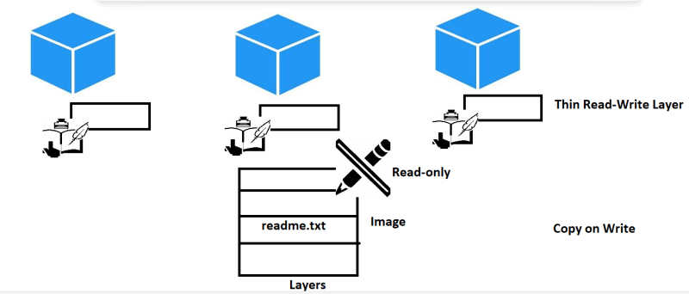

Picturization view of copy on write

